University of Delhi

Ram Lal Anand College

Java Project

**Snake Game**



Group member 1 :- Garima Arora - 20058570009

Group member 2 :- Kanika Vashisht - 20058570017

CERTIFICATE

This is to certify that Garima Arora and Kanika Vashisht of the course B.Sc.(Hons.) Computer Science have successfully completed the Java Project for the academic session April – July 2021 under the guidance of Ms. Shikha Verma.

ACKNOWLEDGEMENT

Firstly , I would take this opportunity to express my gratitude to my teacher Ms. Shikha Verma for her vital support and constant guidance in completing the project.

I would like to thank my parents for their constant support and their valuable suggestions in the make-over of this project.

Last but not the least, I would like to thank my team mate Garima for her dedication throughout the project.

Kanika Vashisht

ABOUT THE PROJECT

The player controls the snake through the keyboard. As we control the snake it changes its coordinates on the board leaving the impression of a moving snake. Initially the snake has a fixed length (a head and two dots representing the tail of the snake). The length of the tail increases as the snake consumes the apple , which appears at random positions on the board. The player loses when the snake runs into the screen borders or collides with itself.

EXPLANATION OF THE CODE

First we made a package named game. Inside the game package we made two java files Snake.java and Board.java.

Snake.java file is our main file which contains static void main and Board.java is the file which contains all the functionality of the game.

In Board.java we imported all the required packages and declared a class named Board which extends JPanel and implements Action Listener interface.

Inside the Board constructor we added keylistener and set the dimension of our panel to be 500x500 and the background color as black. We called two methods loadImages() and initGame().

**Inside loadImages() method :-**

We added three images – an apple , a head and a dot representing the tail of the snake.

**Inside initGame() method :-**

Inside initGame() we are forming the body of our snake which initially consists of three dots .

After this we call the locateApple() method and we control the motion of the snake using a timer.

**Inside locateApple() method :-**

We are defining coordinates of the apple where it randomly appears.

**Inside checkApple() method :-**

In checkApple() we check whether the snake consumes the apple or not . If it does then the length of the snake increases by one.

**Inside move() method :-**

We are setting the snake into motion according to the key pressed by the user.

**Inside checkCollision() method :-**

We are checking if our snake collides with the screen borders or its tail.

Inside the KeyAdapter class we declared all the key events.

1.) Starting point of the game :-

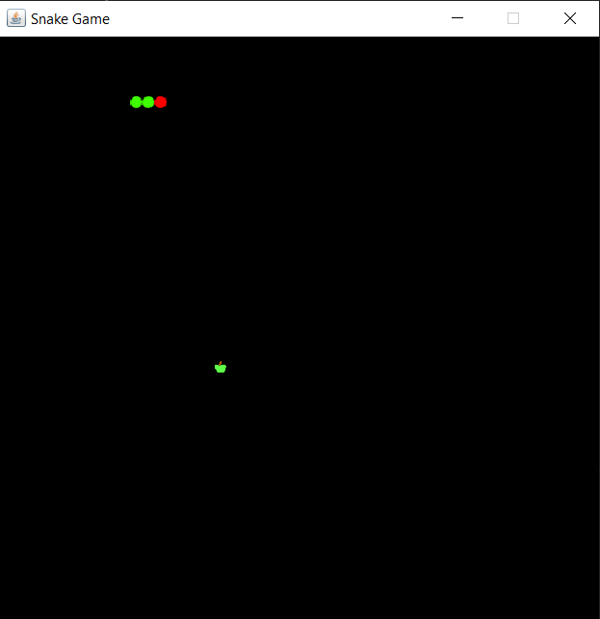

2.) After consuming some apples :-

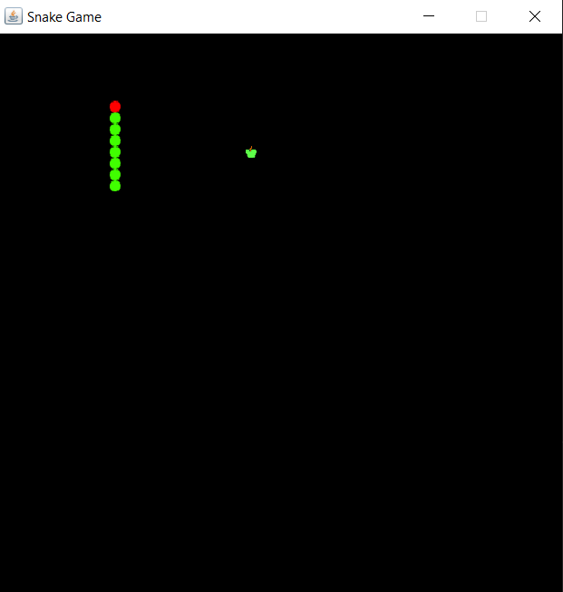

3.) When the snake runs into the screen borders or collides with itself :-

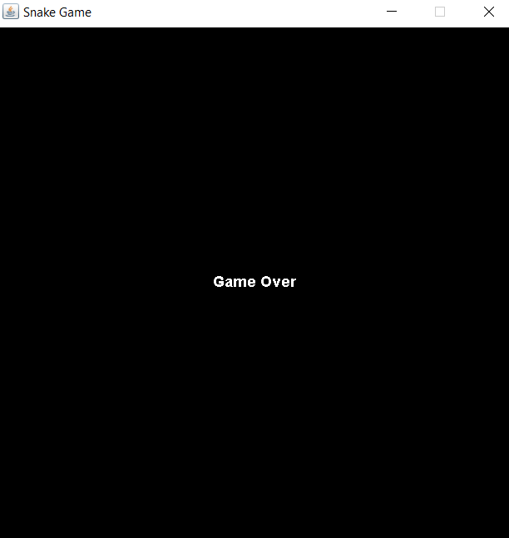

BIBLIOGRAPHY

1. Java - The Complete Reference Tenth Edition Herbert Schildt
2. Youtube : Code for interview